Brain Tumor MRI Classification Using Deep Learning

Your Name: Shruthi Modem
Student ID: 17118820
Project Coventry University GitHub Link:
https://github.com/shruthimodem/deep_learning_course_work

1. INTRODUCTION
Brain tumour is one of the most devastating conditions of the nervous system and early and accurate diagnosis is necessary to enhance the treatment of patients and their prognosis. Magnetic Resonance Imaging (MRI) is a widely used technique to diagnose brain tumors as it provides detailed imaging of the brain tissues. But manually analysing MRI scans is time-consuming, requires expertise of radiologists to do it, and can result in errors in diagnosis if lots of images are analysed. Hence, an automated brain tumour classification system is essential to assist the diagnosis process to be faster and more reliable.

In this project, a deep learning-based system is to be developed that will classify brain MRI images into four classes: glioma, meningioma, pituitary tumor, and no tumor. The two pre-trained, convolutional neural network models used were MobileNetV2 and EfficientNetB0 with transfer learning techniques. To enhance model performance and minimize overfitting, the MRI images were preprocessed by resizing, normalizing data, and applying data augmentation methods. The following metrics: accuracy, precision, recall, F1-score, confusion matrix, and ROC curves were used for the evaluation of the models. The experimental results revealed that EfficientNetB0 exhibited the best accuracy of about 85% on the validation set, highlighting its ability to classify and automatically assist clinicians in making decisions regarding brain tumor classification..

2.DATASET PREPARATION

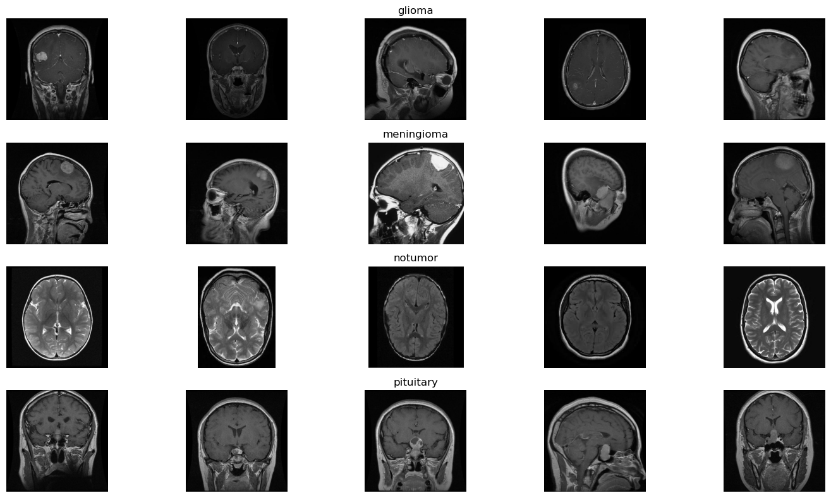
The MRI images in this project are taken from the Brain Tumor MRI Dataset containing 4 classes of brain MRI images: glioma, meningioma, pituitary tumor, and no tumor. Data is split into separate folders for training and testing to facilitate model development and evaluation. The size and shape of the tumor, location, orientation and quality of the images differ between the MRI images making the classification task more realistic and challenging. All images were preprocessed to a fixed input size prior to training and converted to tensors.All images were preprocessed to a fixed input size before training and converted to tensors. To reduce overfitting and enhance the model generalisation, data augmentation techniques including random rotation.
Figure 2.1: Sample MRI images from the Brain Tumor MRI Dataset showing the four classes: Glioma, Meningioma, No Tumor, and Pituitary Tumor.

3.DEVELOPED DEEP LEARNING MODEL
The aim of this project is to create an automated deep learning system that classifies brain Magnetic Resonance Imaging (MRI) images into four categories: glioma, meningioma, pituitary tumor, and no tumor. For this purpose, two transfer learning models were developed and tested: MobileNetV2 and EfficientNetB0, both performed with the PyTorch deep learning framework. Transfer learning was chosen due to its ability to leverage features extracted from a large set of images and help reduce the amount of time required to train a CNN for classification. By comparing the two models, it was determined that the architecture which was more effective for predicting brain tumor classification was identified.
As a result of their lightweight architecture and computational efficiency, the first model (MobileNetV2) was chosen as the baseline model. MobileNetV2 employs depthwise separable convolutions, inverted residual blocks, linear bottlenecks that decrease the number of trainable parameters without compromising the classification accuracy. The design features make the model suitable for medical image classification and especially in the context of limited computational resources.

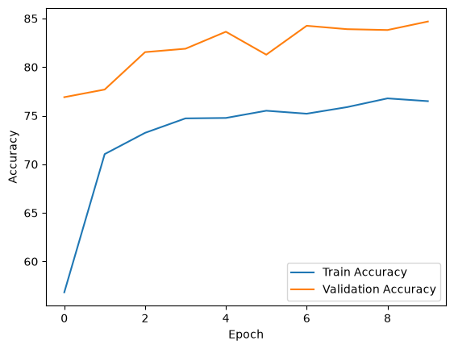
Figure 3.1 Training and Validation Accuracy Curves of the MobileNetV2
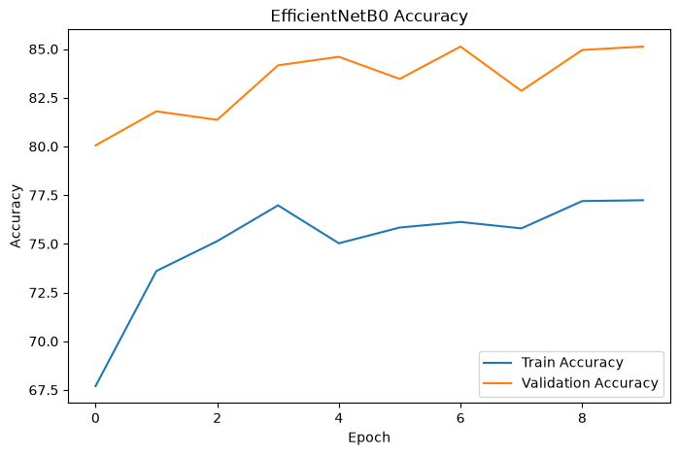
EfficientNetB0 model was implemented for enhancing classification. To achieve this, EfficientNetB0 proposes a compound scaling strategy, where the depth, width and input image resolution of the network are scaled simultaneously in a balanced way. The subtle differences of the MRI images were expected to lead to better feature representation, and improved classification accuracy for EfficientNetB0.
Figure 3.2 Training and Validation Accuracy Curves of the EfficientNetB0
Brefore training, the Brain Tumor MRI dataset was preprocessed by downscaling all images to 224 × 224 pixels and converting them to tensors. The training images were randomly horizontally flipped and rotated to increase the robustness of the model. These pre-processing steps enhanced the diversity of the images, minimized the overfitting, and boosted the model's capacity to generalise to unseen MRI images. To test the model in an objective manner, the dataset was split into training and validation sets.
Both models had been trained using CrossEntropyLoss function and the Adam optimiser. The classification layer was replaced by using transfer learning, with the pre-trained ImageNet feature extractor being used. The model parameters were fine tuned during the training to minimise classification error with the use of backpropagation algorithm; and the best model was automatically saved for testing.
The performance of the developed models was evaluated by accuracy, precision, recall, F1 score, confusion matrix and ROC curves. MobileNetV2 was able to get an overall validation accuracy of around 84%, while EfficientNetB0 was able to get around 85% along with higher precision, recall, and an F1-score value. Thus, EfficientNetB0 was chosen as the final model as it produced the best classification accuracy with enough computational efficiency that it can be used as a reliable method for automated brain tumor classification and computer-aided medical diagnosis.

4.RESULTS AND DISCUSSIION
The aim of this project is to create an automated deep learning system that classifies brain Magnetic Resonance Imaging (MRI) images into four categories: glioma, meningioma, pituitary tumor, and no tumor. For this purpose, two transfer learning models were developed and tested: MobileNetV2 and EfficientNetB0, both performed with the PyTorch deep learning framework. Transfer learning was chosen due to its ability to leverage features extracted from a large set of images and help reduce the amount of time required to train a CNN for classification. By comparing the two models, it was determined that the architecture which was more effective for predicting brain tumor classification was identified.
As a result of their lightweight architecture and computational efficiency, the first model (MobileNetV2) was chosen as the baseline model. MobileNetV2 employs depthwise separable convolutions, inverted residual blocks, linear bottlenecks that decrease the number of trainable parameters without compromising the classification accuracy. The design features make the model suitable for medical image classification and especially in the context of limited computational resources. The fully connected final layer was altered to perform a classification over the four classes of interest rather than the ImageNet classes.
EfficientNetB0 model was implemented for enhancing classification. To achieve this, EfficientNetB0 proposes a compound scaling strategy, where the depth, width and input image resolution of the network are scaled simultaneously in a balanced way. This method allows to get more effective and discriminating features from the network without increasing its computational complexity. The subtle differences of the MRI images were expected to lead to better feature representation, and improved classification accuracy for EfficientNetB0.
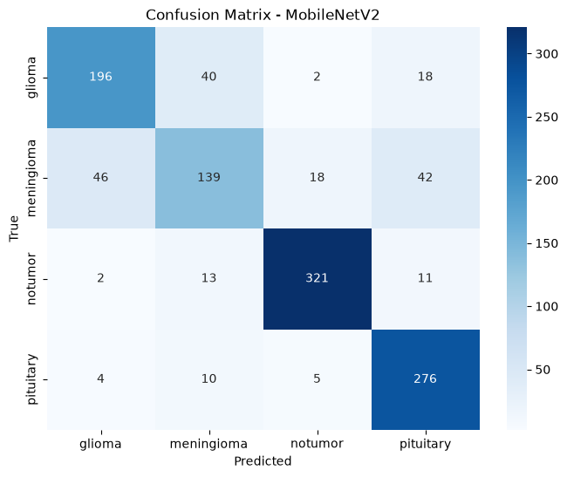
Figure 4.1: Confusion Matrix of the MobileNetV2 Model for Brain Tumor Classification
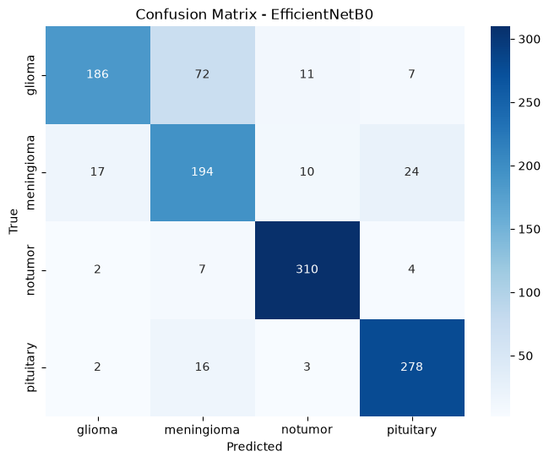

Figure 4.2: Confusion Matrix of the EfficientNetB0 Model for Brain Tumor Classification

Brefore training, the Brain Tumor MRI dataset was preprocessed by downscaling all images to 224 × 224 pixels and converting them to tensors. The training images were randomly horizontally flipped and rotated to increase the robustness of the model. These pre-processing steps enhanced the diversity of the images, minimized the overfitting, and boosted the model's capacity to generalise to unseen MRI images. To test the model in an objective manner, the dataset was split into training and validation sets.
Both models had been trained using CrossEntropyLoss function and the Adam optimiser. The classification layer was replaced by using transfer learning, with the pre-trained ImageNet feature extractor being used. The model parameters were fine tuned during the training to minimise classification error with the use of backpropagation algorithm; and the best model was automatically saved for testing.

Model | Precision | Recall | F1-score | average
Mobilenetv2 | 0.84 | 0.84 | 0.83 | 84%
EfficientnetvB0 | 0.86 | 0.85 | 0.85 | 85%

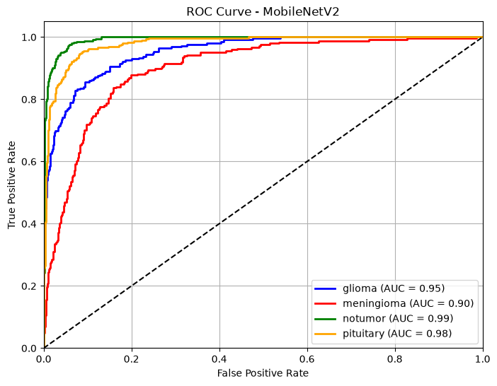
Table 1. In this section, we compare the performance of MobileNetV2 and EfficientNetB0.We compare the performance of MobileNetV2 and EfficientNetB0 in this section.

Figure 4.3: ROC Curve of the MobileNetV2 Model for Brain Tumor Classification
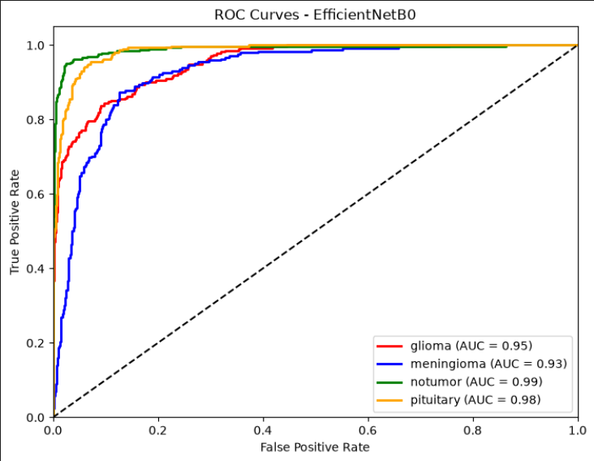
Figure 4.4: ROC Curve of the EfficientNetB0 Model for Brain Tumor Classification
The performance of the developed models was evaluated by accuracy, precision, recall, F1 score, confusion matrix and ROC curves. MobileNetV2 was able to get an overall validation accuracy of around 84%, while EfficientNetB0 was able to get around 85% along with higher precision, recall, and an F1-score value. These findings indicate that EfficientNetB0 outperforms the other nets in the feature extraction ability and generalisation performance in the four tumor types. Thus, EfficientNetB0 was chosen as the final model as it produced the best classification accuracy with enough computational efficiency that it can be used as a reliable method for automated brain tumor classification and computer-aided medical diagnosis.

5.COMPUTATIONAL ASPECTS
The experiments were performed on a Windows laptop with Visual Studio Code (VS Code) with support of PyTorch deep learning framework and Jupyter Notebook. The training time was longer compared to GPU based training due to training being performed on CPU. In the implementation phase, the computational requirements were slightly longer training time, a high memory requirement, and slower convergence speed of the model, especially for EfficientNetB0, which is a deeper network. Transfer learning also lowered the computational expense and pre-trained ImageNet weights were used instead of training the models from scratch. The number of parameters in MobileNetV2 is about 3.5 million while EfficientNetB0 contains about 5.3 million parameters, which is a trade-off between efficiency and accuracy.

6. ETHICAL CHALLENGES
Deep learning in brain tumor classification has raised various ethical and social problems. Patient privacy and data security must be ensured since MRI scans have sensitive medical information. The second one is algorithmic bias, in which an dataset can cause the model to perform less well on certain patient groups, which can result in unfair treatment. Moreover, errors in prediction can have a negative impact on clinical decisions without expert oversight. Thus, the developed system must be regarded as a tool for aiding radiologists rather than as a substitute for the medical judgment of the radiologist. To guarantee reliable and ethical deployment in healthcare and regular updates of the model are essential.

